1. 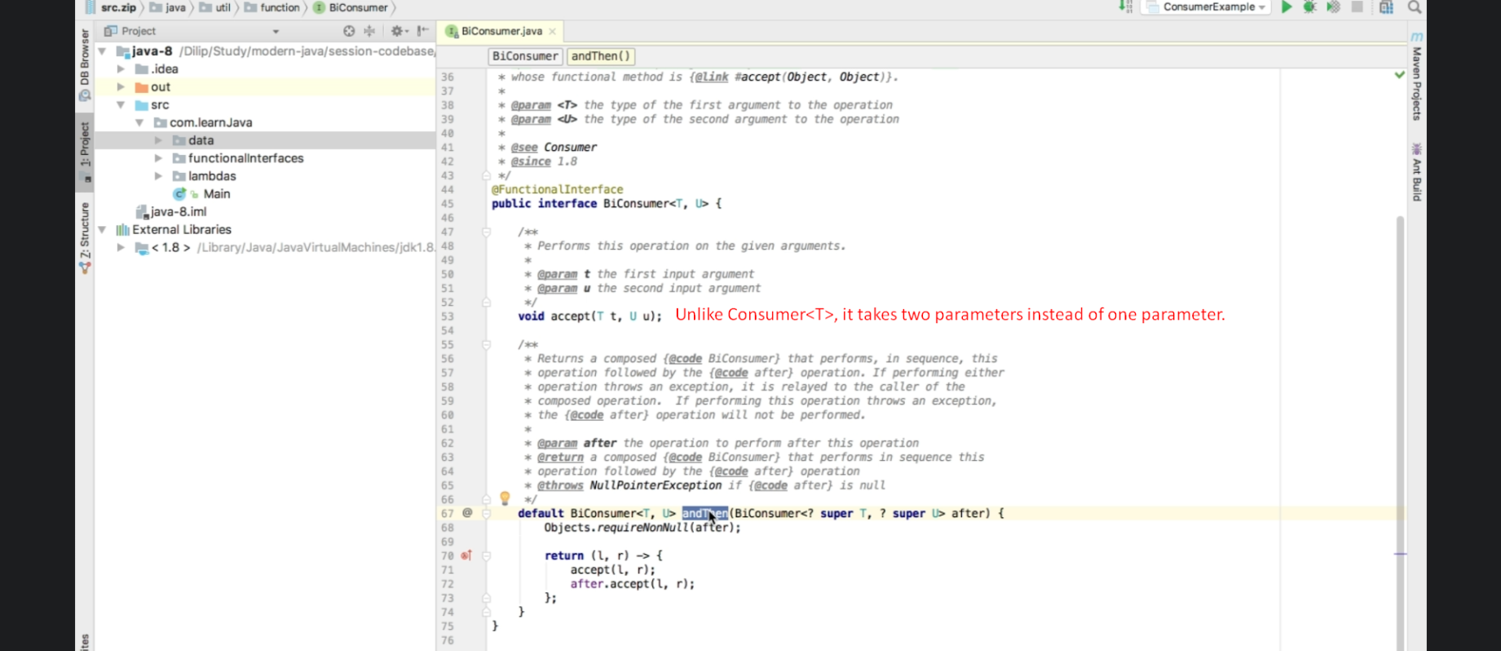
2. NOTE: On line# 17, to forEach, we’re passing just consumer but this consumer uses biConsumer internally.